**S3 BUCKET**

1. Create S3 bucket and upload some objects to S3.

Go to AWS Console >> S3 >> Create bucket.

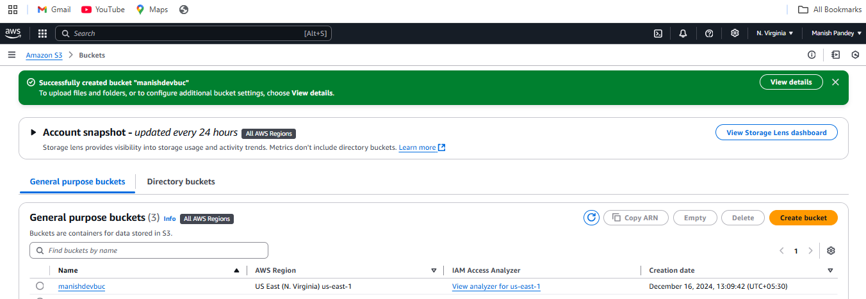

Go to the bucket in which you want to upload the object >> Upload >> Add files >> Upload.

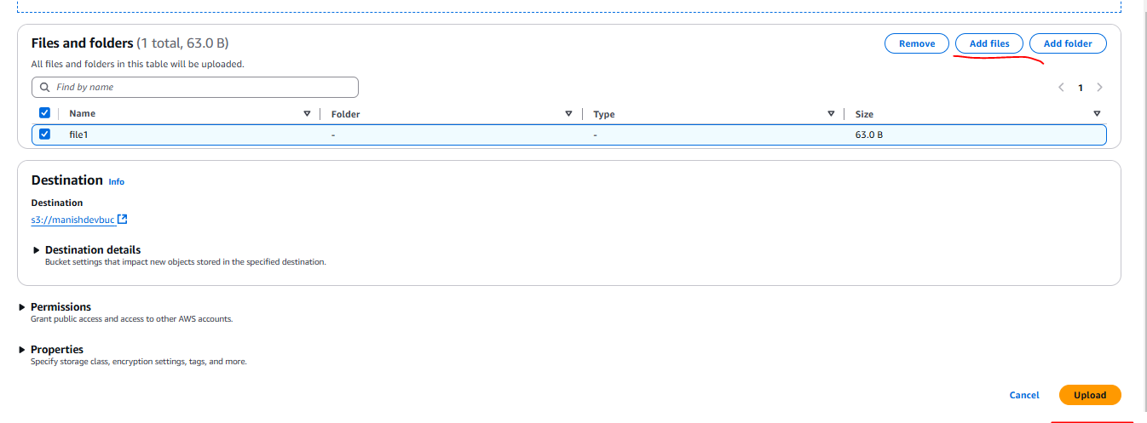

Open file >> Object actions >> Make public using ACL >> Copy object URL and browse.

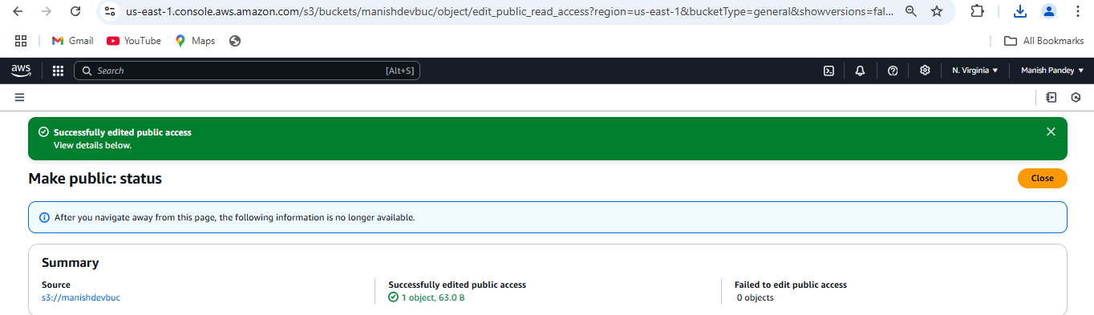

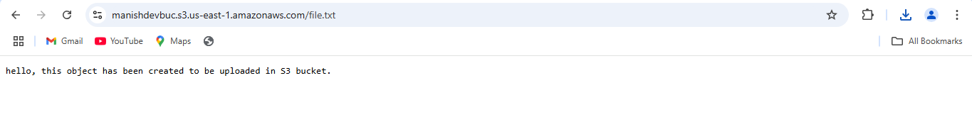

1. Deploy static website in S3 bucket.

Amazon S3 >> Buckets >> Choose bucket >> Properties >> Static website hosting >> Edit >> Enable >> Host a static website >> Index document >> Error document >> Save changes.

Copy bucket URL under Static website hosting.

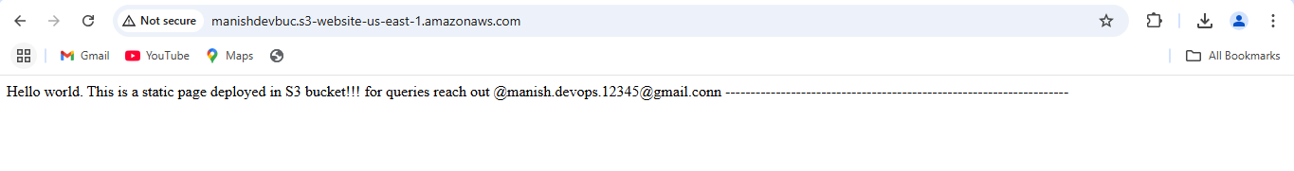

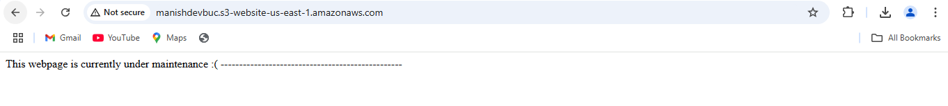

1. Enable cross region replication on S3 buckets.

* Create one S3 bucket in 2 different regions.
* Replication requires versioning to be enabled for the source bucket. Enable versioning in both S3 buckets.
* Source bucket:
* AWS S3 >> Buckets >> Choose source bucket >> Management >> Create replication rule.
* Add file in source bucket and check if it appears in destination bucket.

SOURCE BUCKET

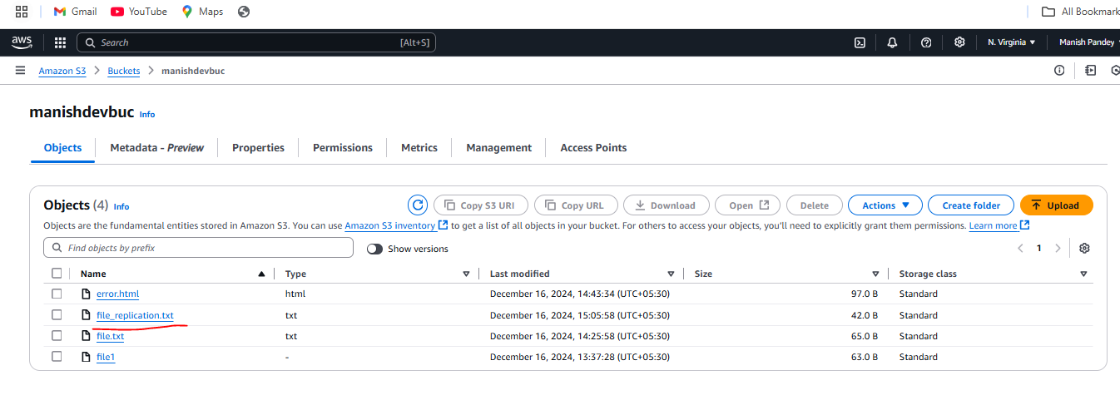

DESTINATION BUCKET

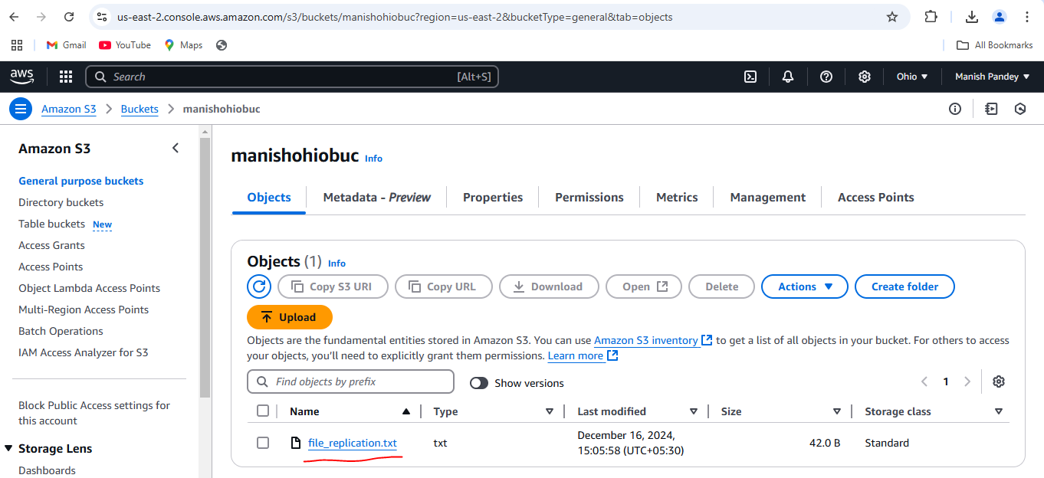

1. Configure bucket policy, only Admin user can see the objects of S3 bucket.

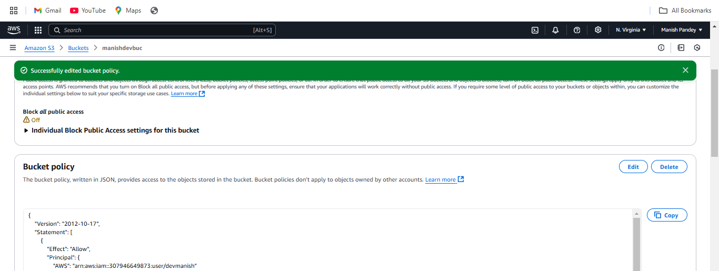

{

"Version": "2012-10-17",

"Statement": [

{

"Sid": "AllowAdminAccess",

"Effect": "Allow",

"Principal": {

"AWS": "arn:aws:iam::307946649873:user/devmanish"

},

"Action": "s3:*",

"Resource": [

"arn:aws:s3:::manishdevbuc",

"arn:aws:s3:::manishdevbuc/*"

]

},

{

"Sid": "DenyNonAdmins",

"Effect": "Deny",

"Principal": "*",

"Action": "s3:*",

"Resource": [

"arn:aws:s3:::manishdevbuc",

"arn:aws:s3:::manishdevbuc/*"

]

}

]

}

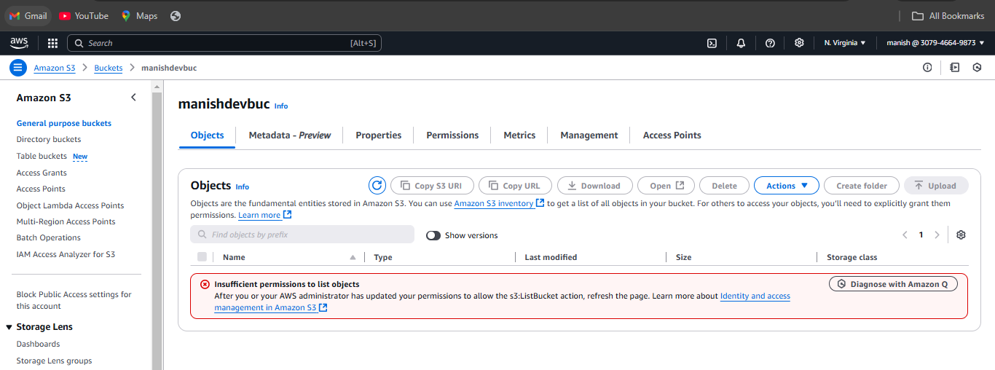

1. Setup lifecycle policies to automatically transition or delete objects based on specific criteria.

Amazon S3 >> Buckets >> Choose bucket >> Management >> Create lifecycle rules

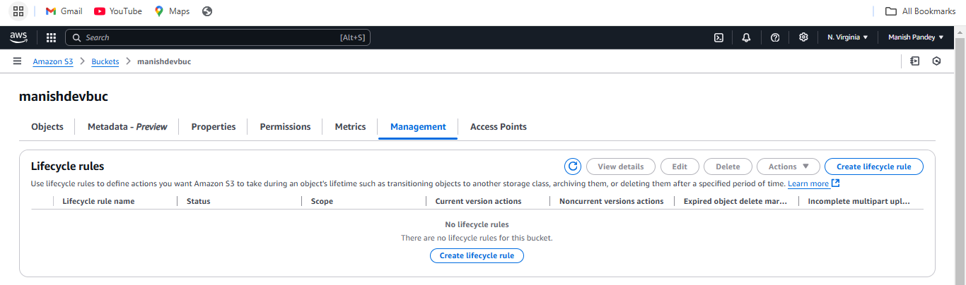

Make selection based on specific criteria.

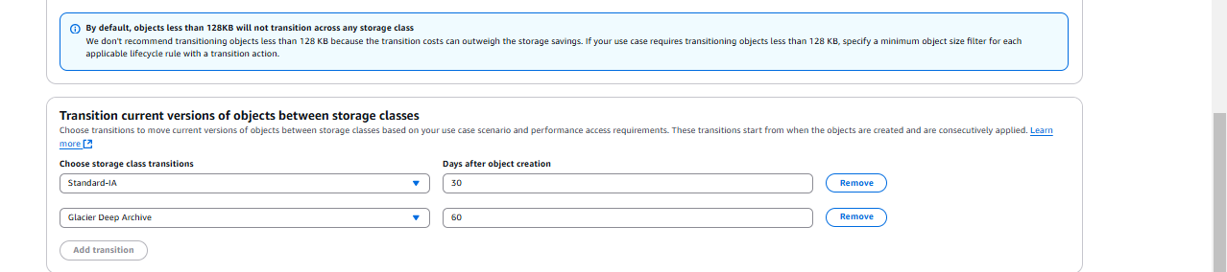

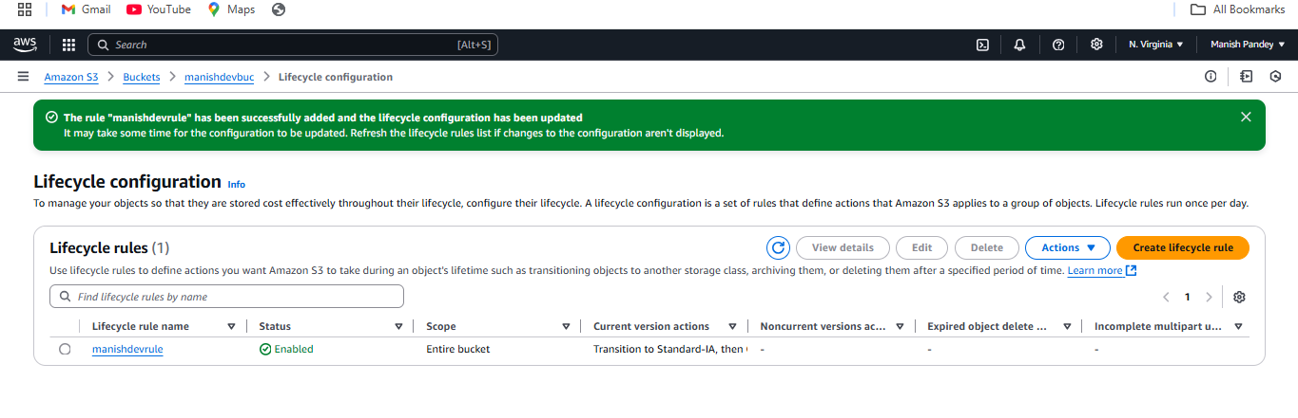

1. Push some objects in S3 using AWS CLI.

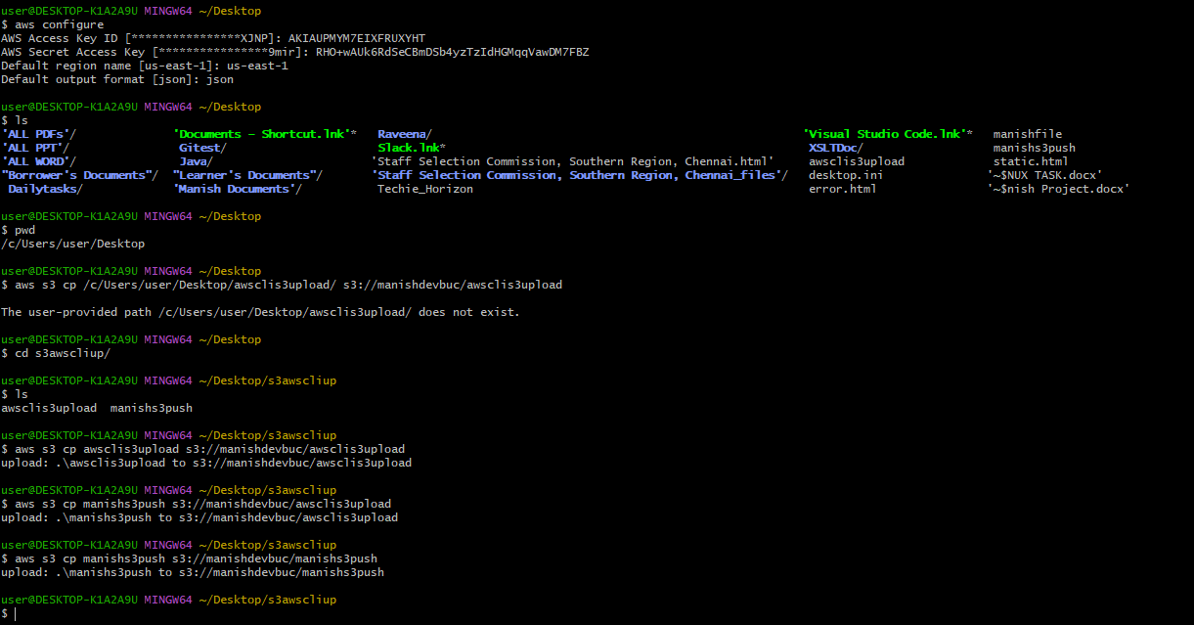

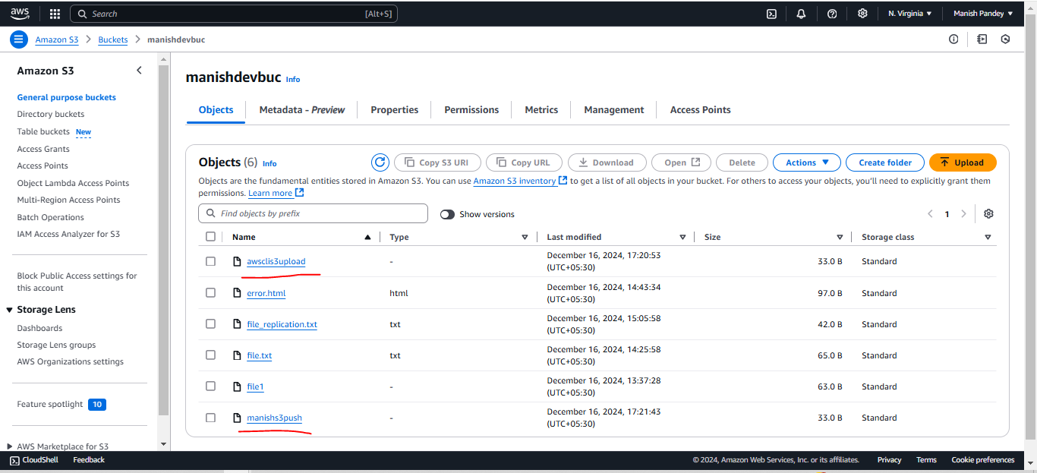

1. Write a bash script to create S3 bucket.

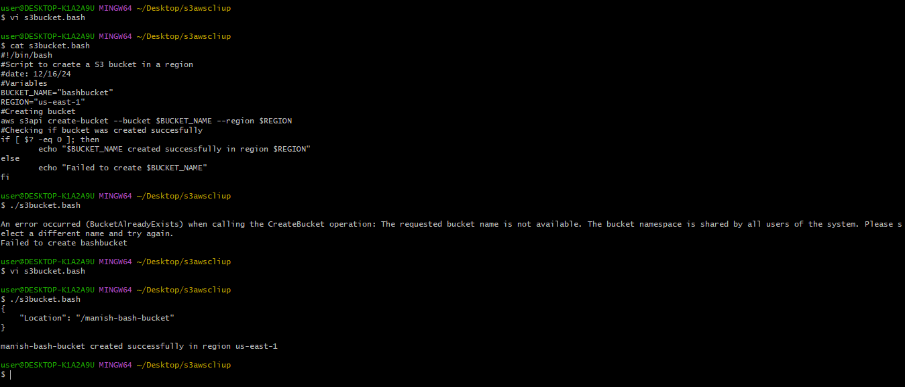

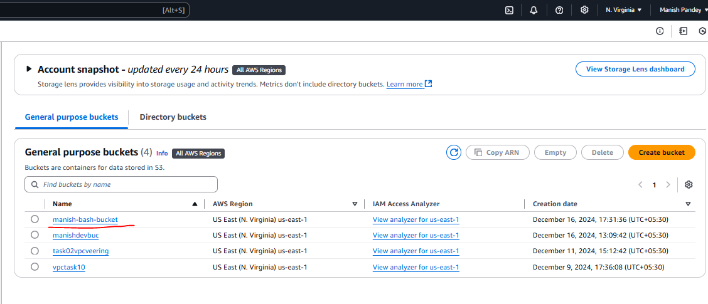

1. Upload 1GB of file to S3 using CLI.

